ART WITH WORDS
Spread the word!!! Hunter Hospitality House, Inc. is sponsoring the Fifth Annual Art Contest for St. Clair County middle school and high school students! Contestants are asked to create an “Art with Words” drawing (sample below).
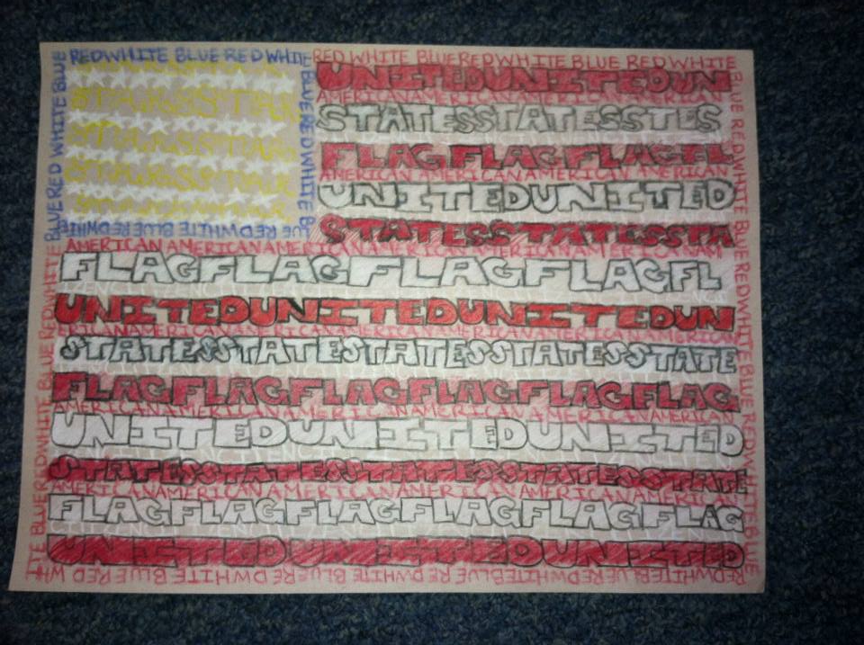
Students can use the medium, subject manner, words, and paper size of their choice. Entries will be judged on artistic merit, creativity and readability of the words. The back of the drawing must include name, address, phone number, age, grade, and school (homeschool students are welcome to enter, too). Winners will be notified by phone.
1st Place Prize: $50 Gift Card (Visa) 2nd & 3rd Place: $25 Gift Card (Visa)
**The WINNER will go on to create a larger Art with Words piece for Hunter Hospitality House, using the names of contributors from 2016 who have given $100 or more to our organization. HHH will supply the materials necessary for that drawing, which will hang inside of HHH for all of our guests and volunteers to enjoy. It will also be displayed at the annual Hope Blooms fundraising event for HHH on April 29, 2017 at the Blue Water Convention Center. The winner will receive two free tickets to Hope Blooms, and will be honored at the event.
Mail entries to: HHH Art Contest 1010 Lincoln Ave. Port Huron, MI 48060.
All entries must be received by February 14, 2017, without exception. Due to the volume of entries we receive, entries cannot be returned.

