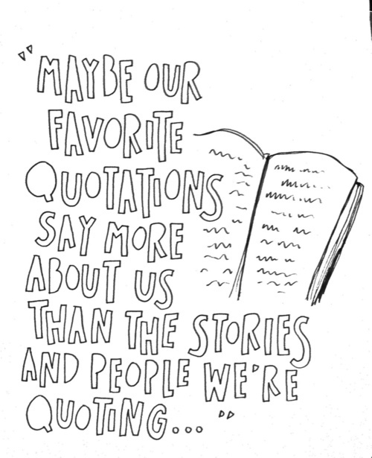
I asked.
They answered.
I wrote.
-Sebastian Junger
6 Word Memoir
Background Story: Legend has it that Ernest Hemingway, a famous and celebrated author, was once challenged to write a story using only six words. Launched online in 2006, SMITH Magazine has attempted just that, celebrating storytelling by setting up a contest and asking both professional writers and aspiring writers to tell their own story using merely six words. Soon, the magazine was flooded through Twitter posts, cell phone texts, mail collections, and phone calls, with people all submitting their short life stories.
Below are some examples:
Wolf! She cried. No one listened.
Wasted time regretted
So life reinvented.
Says deaf boyfriend: you’re too quiet.
Seeking route, not sure of destination.
When all else fails, start running.
Pay attention to me! Go away.
Made some good choices, got lucky.
I was a Michael Jackson impersonator.
Followed rules. Not dreams. Never again.
Happiness is a warm salami sandwich.
Laughter and inappropriate humor since 1994.
Four eyes
are better than two.
Ask for love.
Received confusion.
Still waiting.
At the end of normal street.
I live the perfect
imperfect life.
Fifteen years since last professional haircut.
Did I miss a deadline again?
Saw the world; now where’s home?
“To make a long story short…”
- Directions:
  - Step 1: (beginning in class) After brainstorming using the attached prompts, create a six word phrase that reflects who you are as an individual; your thoughts, your beliefs, or your opinion on something. These six words can be meaningful, poetic, goofy, sad, etc. Please be sure to include your name and class period somewhere on the index card.

  - Step 2: (out of class) Use the 6-word memoir to inspire an illustration or design. USE THE 6 WORD MEMOIR SOMEWHERE IN YOUR PICTURE.
We will display these in class, so please watch any profanity.
Brainstorming Prompts
Answer the questions below to help come up with some ideas for your memoir. Remember that a memoir often tells about a person’s character through a description of a significant event.
What makes you unique?

What was the biggest disappointment or struggle in your life so far?

What was the biggest success or accomplishment in your life so far?

What are you passionate about?

Describe a talent or flaw you have that seems to be in your genes?

Where did you come from? (be creative in your response!)

Where are you going?

If you were a kind of salsa, what kind would you be? (Mild, spicy, etc.)

